Mid-Hudson Chemist

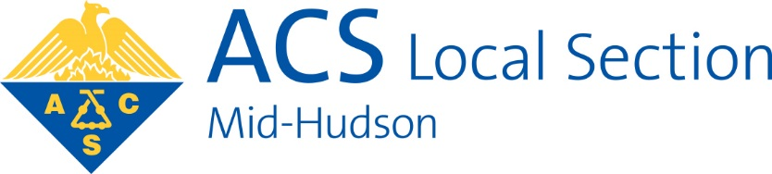

Spring 2020

Upcoming Events

**61st Annual Dutchess County Regional Science Fair**

Place: Dutchess Community College

Date: **Saturday, March 28**

Time: 9:30 am – 12:30 pm (see page 3 for details)

ACS talk on “Chemistry of 3-D Printing”

Speaker: Dr. Dan Freedman

Place: SUNY@New Paltz (room TBD)

Date: Tuesday, March 31

Time: 7:00 pm

**ACS Earth Day Hike**

Place: Starting point is at Mt Taurus parking lot just south of Cold Spring on 9A.

Time: 9:30 am until mid-afternoon

Date: **Saturday, April 18** (rain date April 25)

Please see details on page 4.

**21st ANNUAL MID-HUSON ACS UNDERGRADUATE RESEARCH SYMPOSIUM**

Guest Speaker: Dr. Mostafa A. El-Sayed

Place: Mount Saint Mary College

Date: **Monday, April 27**

Please see announcements on pages 5-10.

SAVE THE DATE

The upcoming URS talk and dinner at

*Mount Saint Mary College on Monday, April 27*.

Please see details about this event on pages 5-10.

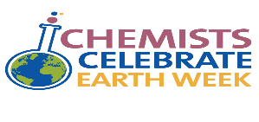

***See 2020 CCEW Illustrated Poem Contest details***

***and entry form on pages 11-12.***

***See the 2019 National Chemistry Week poetry contest***

***entry winner with the theme “Marvelous Metals” on***

***page 13.***

**Hudson Valley Science Café**

A Science Café is a monthly gathering in a café, pub or restaurant, open to the public, with a short presentation of a topic followed by discussion. The essence of a Science Café is informality, with groups seated around tables with food and drink to encourage conversation.

Meetings are on the 4th **Wednesday** of the month, from April to November, except where indicated.  Admission is $3.00 per person.

**Meeting site:** Flaming Grill & Buffet (back party room, but sometimes front), at Newburgh Mall, next to Bed, Bath & Beyond, (1399 Route 300).  Tell the reception when you arrive whether you will be having dinner.  You can arrive at any time, and have as many portions as you like, but please have your last plate in place before the speaker presents at 7:15.  The Buffet is open until 9:30 PM.

**Hudson Valley Science Cafe will be taking its usual winter break from December to March.**

**Meetings to be announced starting in April!**

**Website:** [www.cafescientifique.org/index.php?option=com\_content&view=article&id=196:hudson-valley&catid=78:cafe-pages](http://www.cafescientifique.org/index.php?option=com_content&view=article&id=196:hudson-valley&catid=78:cafe-pages)

Hudson Valley Science Café has received start-up funds from WGBH-NOVA and the American Chemical Society. For information, or to suggest a speaker (yourself included), please contact Dr. Toby Rossman ([tobyrossman@yahoo.com](mailto:tobyrossman@yahoo.com)).

Hudson Valley Science Café is on Facebook: [www.facebook.com/hudsonvalleysciencecafe](http://www.facebook.com/hudsonvalleysciencecafe)

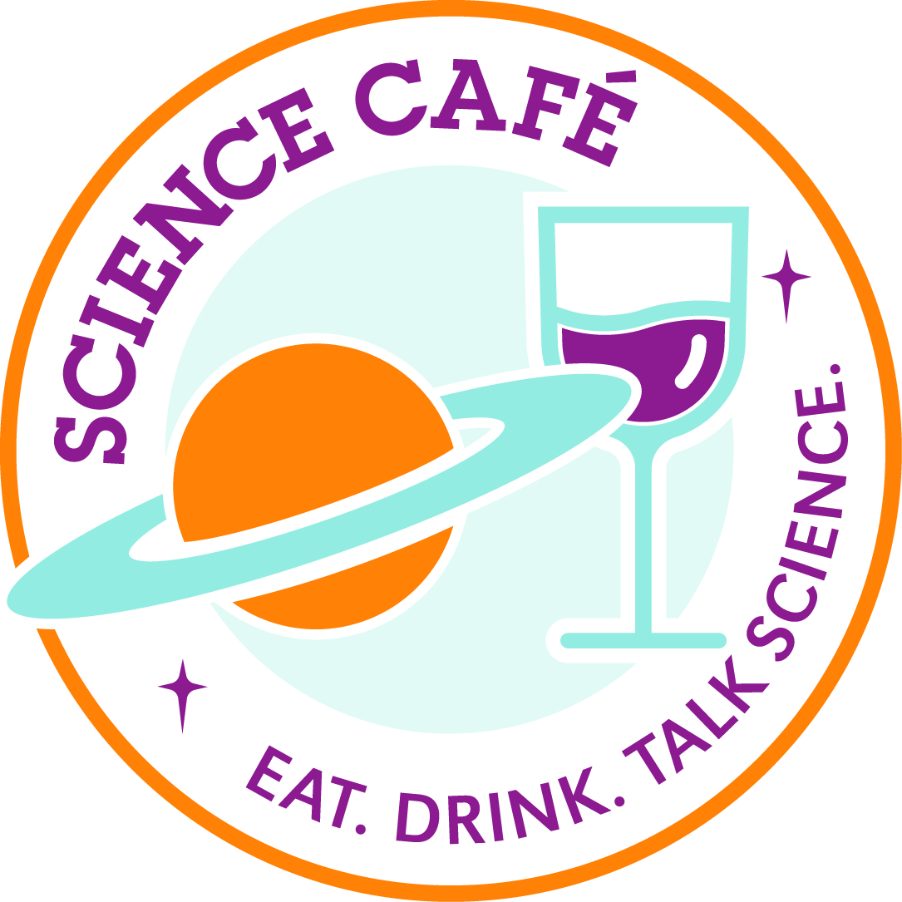

**Chair:** John Edwards; **Chair-Elect:** Lori Wojciechowicz; **Past Chair**: Maryellen Sinclair; **Treasurer:** Joan Skinner; **Secretary:** Chi Nguyen; **Councilor:** Lynn Robinson ; **Alternate Councilor:** TBD; **Members–at–Large:** Ines E. Augie, Glenn Roy, and Joseph Tanski; **NCW Co-Chairs:** Cyndy MacMahon and Timothy MacMahon; **Science Olympiad Chair:** Lynn Maelia; **Awards Chair:** Patti Cusatis and Lynn Maelia; **Government Affairs Chair**: Lynn Robinson; **WCC Chair:** Lynn Robinson; **YCC Chair**: William Maelia; **SCC Chair:** Glenn Roy; **Publicity Chair:** Chet Dziobkowski

**Webmaster**: William Maelia; **Membership Chair:** John Edwards ***Mid-Hudson Chemist* Editor/Publisher:** Lori Wojciechowicz

**~Join the Mid-Hudson ACS WCC Discussion List~**

The following website may be used to subscribe, unsubscribe, or view the archive:

[**lists.msmc.edu/mailman/listinfo/wcc-mh**](http://lists.msmc.edu/mailman/listinfo/wcc-mh)

**To post a message to all the list members, send email to**

[**wcc-mh@lists.msmc.edu**](mailto:wcc-mh@lists.msmc.edu)**.**

**Mid-Hudson ACS Website:** [www.midhudsonacs.org](http://www.midhudsonacs.org/)

Please visit our site and contact our Webmasters ([William.Maelia@gmail.com](mailto:William.Maelia@gmail.com) , [patti.cusatis@basf.com](mailto:patti.cusatis@basf.com)) with your comments or additional items to be posted.

Like us on Facebook: [www.facebook.com/MidHudsonACS](http://www.facebook.com/MidHudsonACS)

**~Join the Mid-Hudson ACS Discussion List~**

The following website may be used to subscribe, unsubscribe, or view the archive:

[lists.msmc.edu/mailman/listinfo/acs-mh](http://lists.msmc.edu/mailman/listinfo/acs-mh)

To post a message to all the list members, send email to [acs-mh@lists.msmc.edu](mailto:acs-mh@lists.msmc.edu).

**2020 Executive Committee**

**SCIENCE**

**FAIR!**

**Call for Judges**

**61st Annual Dutchess County Regional Science Fair**

Date: **Saturday, March 28, 2020**

Place: Falcon Hall, Dutchess Community College, Pendell Road, Poughkeepsie, NY

Time:  **9:30 am to 12:30pm**

            More Information: [www.DCSciencefair.org](http://www.dcsciencefair.org/)

If you are interested in volunteering, please use this[SIGNUP FORM.](https://forms.gle/JZg56zLmCTWBcnhZ7)

(This is the direct link: <https://forms.gle/JZg56zLmCTWBcnhZ7> ;  email me if you have any problems using the form).

|  |  |
| --- | --- |
| [/var/folders/st/nwx_7hbd3hb5bhplwl7t1y200000gn/T/com.microsoft.Word/WebArchiveCopyPasteTempFiles/XIhXrZZbSyPvX3BCNHP7z3x8cTCp-liUSH4_DqWUv3BL4jXK_MSG5hdBBK8PdINQbZg6gF4=w1200-h630-p](https://forms.gle/JZg56zLmCTWBcnhZ7) | [61st Dutchess County Science Fair Volunteer Judges](https://forms.gle/JZg56zLmCTWBcnhZ7)  Sign up below to be a Judge for the Mid-Hudson ACS at the Dutchess County Science Fair on Saturday, March 28th, from 9:30 -12:30, at Dutchess Community College. Questions? Contact [Nicoline.kiwiet@marist.edu](mailto:Nicoline.kiwiet@marist.edu)  forms.gle |

Thank you in advance for your support and assistance with the 2020 Dutchess County Regional Science Fair.

Kind regards,

Nicoline J. Kiwiet

[nicoline.kiwiet@marist.edu](mailto:nicoline.kiwiet@marist.edu)

**Chemistry Department**

**Donnelly Hall 104D**

***Marist College***

**Poughkeepsie, NY 12601-1387**

**Tel: 845-575-3000, ext:6380**

**Google Voice: 347-559-1885**

***Help us celebrate***

***The 50th anniversary of Earth Day!***

***Mid-Hudson ACS Earth Day Hike***

***Saturday, April 18th (rain date April 25th)***

**Rivers, Mountains and Ruins:**

We will start at the Mt Taurus parking lot just South of Cold Spring on 9A.  We will cross the street and do a small loop around little Stony Point.  We will see stunning views of the Hudson and Storm King Mountain from River Level.  We will cross the street and proceed up to the summit of Mt Taurus.  Along the way, we will stop to see the remains of what once was a granite quarry.

 It is a direct hike to the top of Mt Taurus where we can look “down” on Break Neck Ridge.  We descend Mt Taurus from the other side and after a hike end up at the remains of the Cornish Estate.  There is plenty to do and explore in these stunning remains of what once was a flourishing estate: Dairy Barns, Ice House and Mansion.  Thomas Cole, the famous landscape painter of the Hudson River, painted several views of Storm King Mt from this area.

 Then back to the parking lot with lots of Hudson River Views.  The loop is a little over 6 miles.

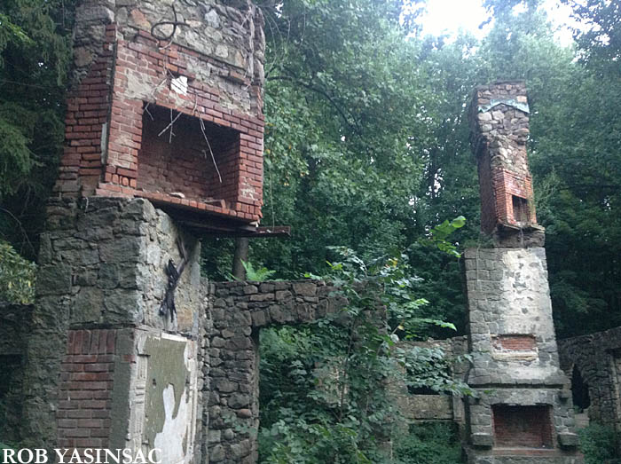 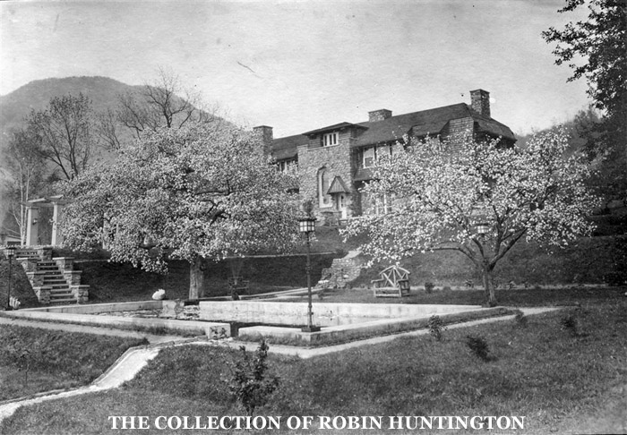

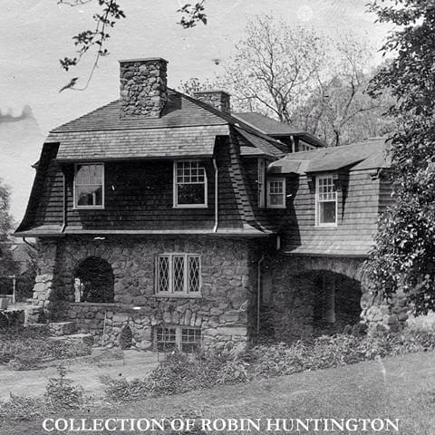 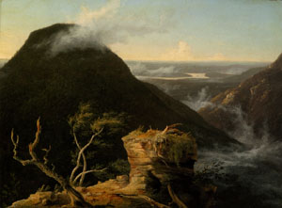

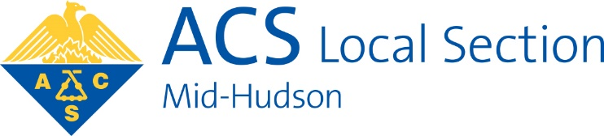

The Mid-Hudson Section of the American Chemical Society and Mount Saint Mary College Present the

**21st Annual Undergraduate Research Symposium**

**Monday, April 27, 2020**

**Mount Saint Mary College**

**Newburgh, NY 12550**

This symposium provides an opportunity for undergraduates from mid-Hudson colleges to present their research in the chemical sciences. All areas of chemistry, environmental science, molecular biology, and related fields are welcome. A poster session will allow students to share their work, followed by an invited lecture and a buffet dinner.

**Symposium Program**

3:30–4:00 PM: Check-In & Poster Set-Up in the Kaplan Center

4:00–4:40 PM: Poster session A

4:40-5:20 PM: Poster session B

5:30–6:00 PM: Awards and Announcements – Hudson Hall

6:00 PM: Lecture by Priestly Medal winner Mostafa El-Sayed

7:00 PM: Buffet Dinner (Reservations required)

**Nanotechnology Enables Hot Gold Nanorods to Kill Cancer Cells and to Stop Alive Sick Cells from Migrating to other Places in the Body**

**Mostafa A. El-Sayed**

School of Chemistry and Biochemistry

Georgia Institute of Technology

Atlanta, GA 30332-0400

Cancer kills many people after years of suffering and unsuccessful treatments like surgery, chemical and/or radiation treatments. The field of Nanotechnology showed us how different materials acquire many different properties when their size is reduced to the nanometer scale. Gold nanoparticles having a rod shape of nanometer size and a length: width ratio of 3:1 can absorb near infrared light (to which our body is transparent) and convert it into heat. If a solution containing gold nanorods is injected into a tumor and exposed to near infrared light, the hot solution (resulting from the gold nanorods absorbing the near infra-red light) melts the cancer cells, leading to their death. This was demonstrated by our group in the photo-thermal destruction of cancer cells in solution and in tumors in small and large animals (1-5). Normally, some of the cancer cells that do not die are able to migrate to other parts of the body away from the location of their initial formation until they are located in a sensitive part of the body that leads to the cancer patient death. Thus, most of the cancer patients die from cancer after the cancer cells migrate by a process called metastasis to a more sensitive part of the body.

Very recently, however, we discovered (5,6) that our photo-thermal treatment, while treating cancer cells in the first cancer location with hot gold nano-rods, also destroys the cancer cell legs and arms and the motion proteins in the body cells. This makes it difficult for the cancer cells to metastasize to other locations in the body. This treatment is thus effective in stopping cancer cell migration through the patient and increases the success rate for complete recovery.

**References**

1. El-Sayed, I. H.; Huang, X.; El-Sayed, M. A., Selective laser photo-thermal therapy of epithelial carcinoma using anti-EGFR antibody conjugated gold nanoparticles. *Cancer letters* **2006,** *239* (1), 129-135.

2. Dickerson, E. B.; Dreaden, E. C.; Huang, X.; El-Sayed, I. H.; Chu, H.; Pushpanketh, S.; McDonald, J. F.; El-Sayed, M. A., Gold nanorod assisted near-infrared plasmonic photothermal therapy (PPTT) of squamous cell carcinoma in mice. *Cancer letters* **2008,** *269* (1), 57-66.

3. Ali, M. R. K.; Rahman, M. A.; Wu, Y.; Han, T.; Peng, X.; Mackey, M. A.; Wang, D.; Shin, H. J.; Chen, Z. G.; Xiao, H.; Wu, R.; Tang, Y.; Shin, D. M.; El-Sayed, M. A., Efficacy, long-term toxicity, and mechanistic studies of gold nanorods photothermal therapy of cancer in xenograft mice. *Proceedings of the National Academy of Sciences* **2017**.

4. Ali, M. R. K.; Ibrahim, I. M.; Ali, H. R.; Selim, S. A.; El-Sayed, M. A., Treatment of natural mammary gland tumors in canines and felines using gold nanorods-assisted plasmonic photothermal therapy to induce tumor apoptosis. *International Journal of Nanomedicine* **2016,** *11*, 4849-4863.

5. Ali, M. R. K.; Wu, Y.; Tang, Y.; Xiao, H.; Chen, K.; Han, T.; Fang, N.; Wu, R.; El-Sayed, M. A., Targeting cancer cell integrins using gold nanorods in photothermal therapy inhibits migration through affecting cytoskeletal proteins. *Proceedings of the National Academy of Sciences* **2017,** *114* (28), E5655-E5663.

6. Ali, M. R. K.; Wu, Y.; Ghosh, D.; Do, B. H.; Chen, K.; Dawson, M. R.; Fang, N.; Sulchek, T. A.; El-Sayed, M. A., Nuclear Membrane-Targeted Gold Nanoparticles Inhibit Cancer Cell Migration and Invasion. *ACS Nano* **2017**. 1936-0851.

**Biography:**

Mostafa A. El-Sayed is a highly cited Egyptian chemical physicist, a leading nanoscience researcher, a member of the National Academy of Sciences and a US National Medal of Science laureate. He is also known for the spectroscopy rule named after him, the *El-Sayed* rule. Dr. El-Sayed earned his B.Sc. from Ain Shams University Faculty of Science, Cairo in 1953. He earned his doctoral degree from Florida State University working with Michael Kasha, the last student of the legendary G. N. Lewis . He spent time as a researcher at Harvard University, Yale University and the California Institute of Technology before joining the faculty of the University of California at Los Angeles in 1961. He is currently the Julius Brown Chair and Regents Professor of Chemistry and Biochemistry at the Georgia Institute of Technology. He heads the Laser Dynamics Lab there with studies in nanoscience and nanotechnology including applications in medicine, catalysis, and plasmonics. Author of over 600 scientific publications, Professor El-Sayed received the 2016 Priestley Medal, the American Chemical Society’s highest honor, for his decades-long contributions to chemistry.

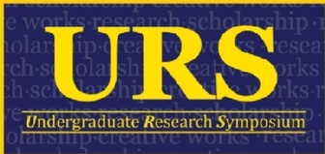**Call for Poster Abstracts:** To present a poster, please submit an abstract of ***200 words or less***. Please make every effort to adhere to the specific formatting guidelines, as follows:

1. Submit each abstract as a separate Microsoft Word file. The filename should include: the first author’s last name, the institution name, and the faculty advisor’s last name.
2. Use 16 point Times New Roman font with one inch margins all around.
3. Do not include references.
4. Include an abstract header with each of the following items centered, on separate lines, and formatted as follows:

* Title: in bold and all caps
* List of authors: in bold and separated by commas. The faculty advisor’s name should be followed by an asterisk (\*).
* Institution Name: in bold
* Institution Address: in bold (e.g., **330 Powell Avenue, Newburgh, NY 12550**)
* Faculty Advisor’s Email Address: in bold and lower case

**Poster Size:** To fit on the poster boards, posters should be approximately 48 inches wide by 36 inches in height.

**Abstract submission:** Please submit your abstract as an email attachment on or before **Friday, April 3** to: [acs@msmc.edu](mailto:acs@msmc.edu) . If you are unable to meet this deadline, please contact Dr. Lynn Maelia ([lynn.maelia@msmc.edu](mailto:lynn.maelia@msmc.edu)) to make arrangements. There is a $25 conference fee per poster up to $400 maximum per school. In addition to your abstract by email, please RSVP by contacting your school’s contact person (listed below) indicating the full names of all the authors who will be attending and whether you will be staying for dinner. Faculty advisors will receive a confirmation email regarding the submitted abstract prior to the event.

**RSVP:** A buffet dinner will be served following the awards and speaker ($25/person). Please RSVP for the symposium and/or dinner by contacting the point person for your school (see list below) by **April 3** and providing the following information: **First and Last name, symposium only or dinner RSVP**. Because your abstract may possibly contain multiple authors, **please be sure to RSVP in addition to submitting your poster, even if you are not staying for the dinner.**

|  |  |  |
| --- | --- | --- |
| **School** | **Contact** | **e-mail** |
| Bard | Swapan Jain | [sjain@bard.edu](mailto:sjain@bard.edu) |
| Marist | Jocelyn Nadeau | [Jocelyn.Nadeau@marist.edu](mailto:Jocelyn.Nadeau@marist.edu) |
| MSMC | Lynn Maelia | [Lynn.maelia@msmc.edu](mailto:Lynn.maelia@msmc.edu) |
| Ramapo | Jay Carreon | [jcarreon@ramapo.edu](mailto:jcarreon@ramapo.edu) |
| SUNY – New Paltz | Megan Ferguson | [fergusom@newpaltz.edu](mailto:fergusom@newpaltz.edu) |
| SUNY Orange | Tim MacMahon | [timothymacmahon@sunyorange.edu](mailto:timothymacmahon@sunyorange.edu) |
| US Military Academy | Chi Nguyen | [chi.nguyen@westpoint.edu](mailto:chi.nguyen@westpoint.edu) |
| Vassar | Linda Ferraro | [liferraro@vassar.edu](mailto:liferraro@vassar.edu) |

**Directions:** Mount Saint Mary College is located at 330 Powell Avenue, Newburgh, NY. Directions can be found at this link:[**https://www.msmc.edu/About\_MSMC/Our\_Location/Directions\_\_Map**](https://www.msmc.edu/About_MSMC/Our_Location/Directions__Map)

We look forward to seeing you all at the 21st annual Mid-Hudson ACS Undergraduate Research Symposium at Mount Saint Mary College. Please check the event website for further details and updates:

<https://www.midhudsonacs.org/undergraduate-research-symposium.html>



**Call for Applications for**

**2020 Undergraduate Student Research Awards**

The Mid-Hudson Section of the American Chemical Society invites applications for the 2020 Mid-Hudson valley ACS Undergraduate Research Awards from student researchers who plan to present their work at the 2020 symposium. **Outstanding submissions will be selected to each receive a monetary award.** This is a separate application and is not required of all students presenting posters only those students who wish to be considered for this very prestigious award need apply.

*Rationale*

The Mid-Hudson Section wishes to reward undergraduate students who choose to write a short summary about their research and scholarship activities.

*Criteria*

Research work should be completed by a student currently enrolled (2019-2020 academic year) as an undergraduate at one of colleges in the Mid-Hudson ACS area. Students must also present their work at the 2020 Mid-Hudson ACS Undergraduate Research Poster Symposium at Mount Saint Mary College on April 27, 2020.

*Application Format and Procedure:*

*All papers submitted must be primarily chemistry, not biology or physics.*

*Format: The paper must be written in Microsoft Word with a font type of New Times Roman and a font size 12. Margins should be set to the Narrow setting under page layout/margins in Word. The description part of the paper may not be longer than two pages; however, the* Acknowledgments and References *may cause the paper to run longer.* ***Any papers longer than the requested two written pages will not be considered.***

The summary should be written in normal scientific format and divided into appropriate sections in the following order:

1) Title with authors: The title of the paper should be at the top with the authors underneath. The student submitting the paper for the award must be clearly indicated. This can be done by bolding and underlining that author.

2) Introduction: Keep in mind that the judges for the paper come from a wide variety of chemical backgrounds and will probably not be familiar with your research or your area of specialization. You need to clearly outline what you are doing and why it is being done. Remember, your audience is not familiar with your research, although they will be professional chemists, so you need to explain it to them in terms they can understand.

3) Experimental: Just a brief review of your experimental design and data is needed.

4) Results and Discussion: This along with the introduction and conclusion are the most important parts of the paper. This is your chance to wow the judges with your fabulous work. Remember the judges will not be familiar with your work so you must educate them. Now after years of learning and studying, is your chance to educate us. Make sure you include all chemical structures, equations and reactions. Remember, although you have spent many hours intimately involved in this research and thus all the reactions and chemicals are as familiar to you as your best buddies, they will be new to the judges. The better the judges understand exactly what you are doing and what you have accomplished the better your chances at winning the award. Do not be shy about drawing chemical structures and writing out the reactions as these are some of the best ways to help other chemists understand exactly what your research is about.

5) Conclusion: This needs to be consistent with the introduction and should obviously quickly summarize what your research has accomplished and if applicable where it will be going in the near future.

6) Acknowledgments and References: This part of the paper may exceed the two-page limit and should be as extensive and comprehensive as needed.

7) In Summary: Again, it is important to remember the judges are not experts in your area of research so your job is to educate them on your research and WOW them with the work you have been doing. This does not mean you have to be overly technical in your writing. You should include all the relevant chemistry being careful to include all important chemical structures and reactions but make sure the paper is readable and flows well. The judges, who are chemists, volunteer their time to judge this competition and will not spend excessive amounts of time trying to decipher cryptic or non-coherent writing. As a parting note, remember the judges must be able to understand exactly what you have accomplished so a poorly organized and poorly worded paper will not impress the judges. Good luck on your submission and the judges are looking forward to learning about your research.

*Submission procedure:*

Applications should be sent by e-mail as an attached Word Document to Dr. Timothy MacMahon e-mail: [timothy.macmahon@sunyorange.edu](mailto:timothy.macmahon@sunyorange.edu) by Monday April 13, 2020. Please indicate in the subject line of the e-mail that you are submitting an application for the URS Student Research Award. Confirmation that the submission has been received will be sent via e-mail

# 2020 CCEW Illustrated Poem Contest

# “Protecting Our Planet through Chemistry”

The Mid-Hudson Local Section of the American Chemical Society (ACS) is sponsoring an illustrated poem contest for students in Kindergarten through 12th grade.

**Contest Deadline: April 17, 2020**

**Prizes: Barnes & Noble gift cards  
Contact: Lynn Maelia, lynn.maelia@msmc.edu**

Winners of the Mid-Hudson Local Section’s Illustrated Poem Contest will advance to the National Illustrated Poem Contest for a chance to be featured on the ACS website and to win prizes!

Write and illustrate a poem using the CCEW theme, “Protecting Our Planet through Chemistry.” Your poem must be **no more** than 40 words and in the following styles to be considered:

**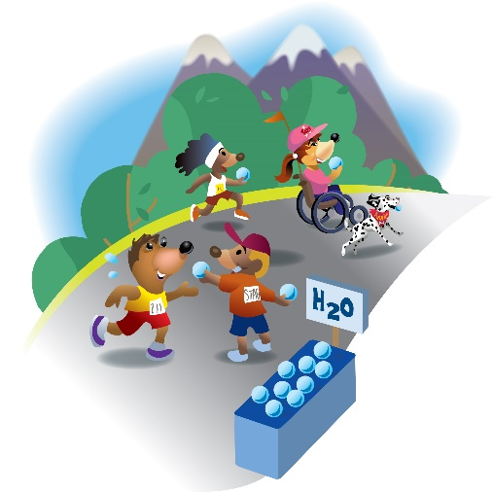HAIKU - LIMERICK - ODE - ABC POEM - FREE VERSE - END RHYME -**

**BLANK VERSE**

**Possible topics related to sustainable chemistry include:**

Green chemistry Environment Pollution

Clean air and water Natural resources Waste

**Entries will be judged based upon:**

Artistic Merit - use of color, quality of drawing, design & layout

Poem Message - fun, motivational, inspiring about yearly theme

Originality Creativity - unique, clever and/or creative design

Neatness - free of spelling and grammatical errors

**Contest rules:**

* All poems must be no more than 40 words, and in one of the following styles to be considered: Haiku, Limerick, Ode, ABC poem, Free verse, End rhyme, and Blank verse.
* Entries are judged based upon relevance to and incorporation of the NCW theme, word choice and imagery, colorful artwork, adherence to poem style, originality and creativity, and overall presentation.
* All entries must be original works without aid from others. Poems may be submitted by hand on an unlined sheet of paper not larger than 11” by 14” or scanned and sent via email. Illustrations may be created using crayons, watercolors, other types of paint, colored pencils, or markers. The illustration may also be electronically created by using a digital painting and drawing app on a computer, tablet, or mobile device.
* The text of the poem should be easy to read and may be typed before the hand-drawn or digital illustration is added, or the poem may be written on lined paper, which is cut out and pasted onto the unlined paper with the illustration.
* No clipart or unoriginal images can be used.
* Only one entry per student will be accepted; all entries must include an entry form. If the illustration is created using a digital painting or drawing app, the name of the program must be included on the entry form.
* All illustrated poems and/or digital representations of the poems become the property of the American Chemical Society.
* Acceptance of prizes constitutes consent to use winners’ names, likenesses, and entries for editorial, advertising, and publicity purposes.

# 2020 CCEW Illustrated Poem Contest

# “Protecting Our Planet through Chemistry” ENTRY FORM

Please fill out this form and attach it after the poem. All fields are required. Incomplete forms will invalidate the entry.

**The deadline for the Mid-Hudson Local Section Contest is April 17, 2020.**

|  |  |  |  |  |  |  |  |  |
| --- | --- | --- | --- | --- | --- | --- | --- | --- |
| **Student and Organization Information** | | | | | | | | |
| Student Name: | |  | | | | | | |
| Student Grade: | |  | | | | | | |
| Parent/Guardian Name: | |  | | | | | | |
| Parent/Guardian Email: | |  | | | | | | |
| Parent/Guardian Address: | |  | | | | | | |
| Parent/Guardian City: | | | | | | State: | | Zip: |
| School or Sponsoring Group *(e.g. Boys and Girls Club or Scout Troop, 4-H, etc.):* | | | |  | | | | |
| Teacher Name: | |  | | | | | | |
| Teacher Email: | |  | | | | | | |
| School Address: | |  | | | | | | |
| School Address 2: | |  | | | | | | |
| School City: | | | | | | State: | | Zip: |
| Please send any follow up for the student to the parent  or school  address. | | | | | | | | |
| **Illustration Type (Check one)** | | | | | | | | |
| Hand-drawn art | | | | | Digitally created art | | | |
| If the poem was digitally created, please name the software used in the box below: | | | | | | | | |
|  | | | | | | | | |
| **Judging Category by Grade (Check one)** | | | | | | | | |
| K-2 | 3-5 | | | | 6-8 | | 9-12 | |
| **FOR LOCAL SECTION USE ONLY** | | | | | | | | |
| Local Section Name: | | | Mid-Hudson | | | | | |
| NCW Coordinator Name: | | | Lynn Maelia | | | | | |
| NCW Coordinator Email/Phone: | | | [Lynn.maelia@msmc.edu/](mailto:Lynn.maelia@msmc.edu/) 845-569-3131 | | | | | |

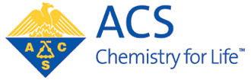

American Chemical Society Poem Contest

sponsored by the

Mid-Hudson Section of the American Chemical Society

The Mid-Hudson Section of the American Chemical Society has chosen the following students to receive recognition for their work and efforts in the 2019 National Chemistry Week poetry contest with the theme “Marvelous Metals”. Students from two schools participated in the contest.

9-12

1st place: Sharie Rhea – Red Hook High School

2nd place: Hannah Roszko – Red Hook High School

3rd place: Rose Snyder – Red Hook High School



1st place 9-12 grade category – Sharie Rhea, Red Hook Central High School

**We’d like to share some photos from last year!**

***West Point cadets celebrate***

***Mole Day 2019!***

